CGT 270 Data Visualization

Makeover Monday #1 (2018 Dataset)

**Name:** Cristina Pascua **Date:** 10/21/21

**Lab section:** Thursday

**Show your work!!!**

# Acquire

Week: 48

Date: Nov. 6 Year: **2018.** Data: https://data.world/makeovermonday/2018w48

Source Article/Visualization:

[The cost of a night out](https://www.thrillist.com/news/nation/cost-of-a-night-out-cities-around-the-world)  
Data Source: [UBS](https://www.ubs.com/microsites/prices-earnings/en/stories/7-dinner-in-paris-party-in-miami-the-cheapest-and-priciest-cities-for-a-night-out/)

<https://www.makeovermonday.co.uk/data/data-sets-2018/>

# Represent

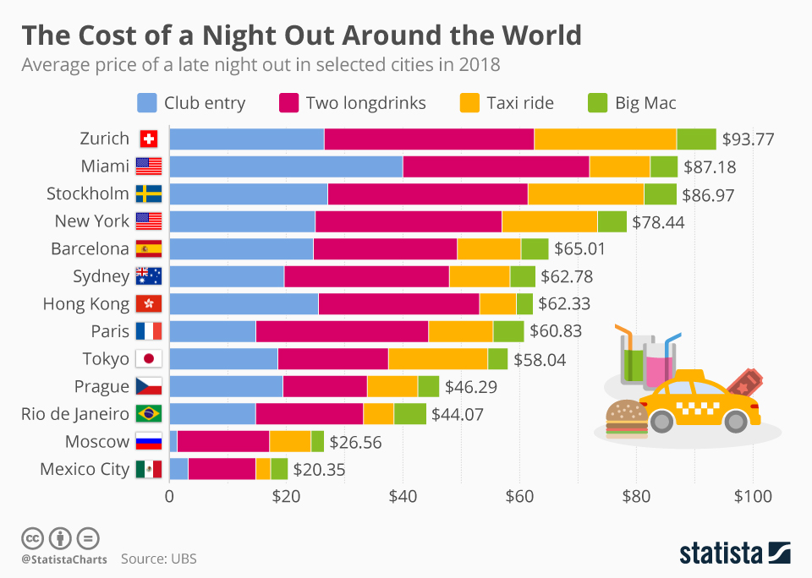

# Critique

Overall, I generally like the visualization. I think using a stack bar graph is a great way to represent and give proper insight to the data. I would probably get rid of the flag icons as they can distract the viewer with their colors and can be unhelpful to those who don’t know the flags of different countries. I would instead probably put the name of the country after or remove it altogether. The graphic in the bottom right can also distract the viewer when trying to read the graph as it is directly on top of the lines. I suppose they counteract this by just putting the sum of the night on each bar, but individual labels are unnecessary with a proper y-axis and further add to the complexity of the visualization.

# Mine

After looking at the entire dataset, I noticed the original visualization only shows the price for a “party” night out. It leaves out three other categorical items that a different kind of night out, “date” night would cost. I wanted to show both as the date night item costs are much higher priced, the highest costing city is different for different kinds of nights out, and for those who want to spend a different kind of night out and want to estimate the price.

**Filter**

I filtered my data by removing the country column as it felt redundant, and for my individual graphs, I filtered each by the category or what kind of night out.

# Stakeholders

* Who is your audience?
  + My audience is people traveling to popular cities who want to know in advance how much money they might spend when they want to go on night out.
* What assumptions did you make?
  + I assume that the prices for each item in a city is the average cost of that item/service throughout the city and that the prices can be higher or lower than the prices shown in the data.
* What visualization tool/software did you use?
  + I used Tableau.

**What to submit:** This document in PDF format only (if you do not know how to do this, ask).

**Choose the best layout** for your makeover visualization

* Portrait or Landscape
* Remove the page of the layout that you DO NOT choose. No blank pages!

CGT 270 Data Visualization

Makeover Monday #1 (2018 Dataset)

**Refine (Makeover – Landscape view)**

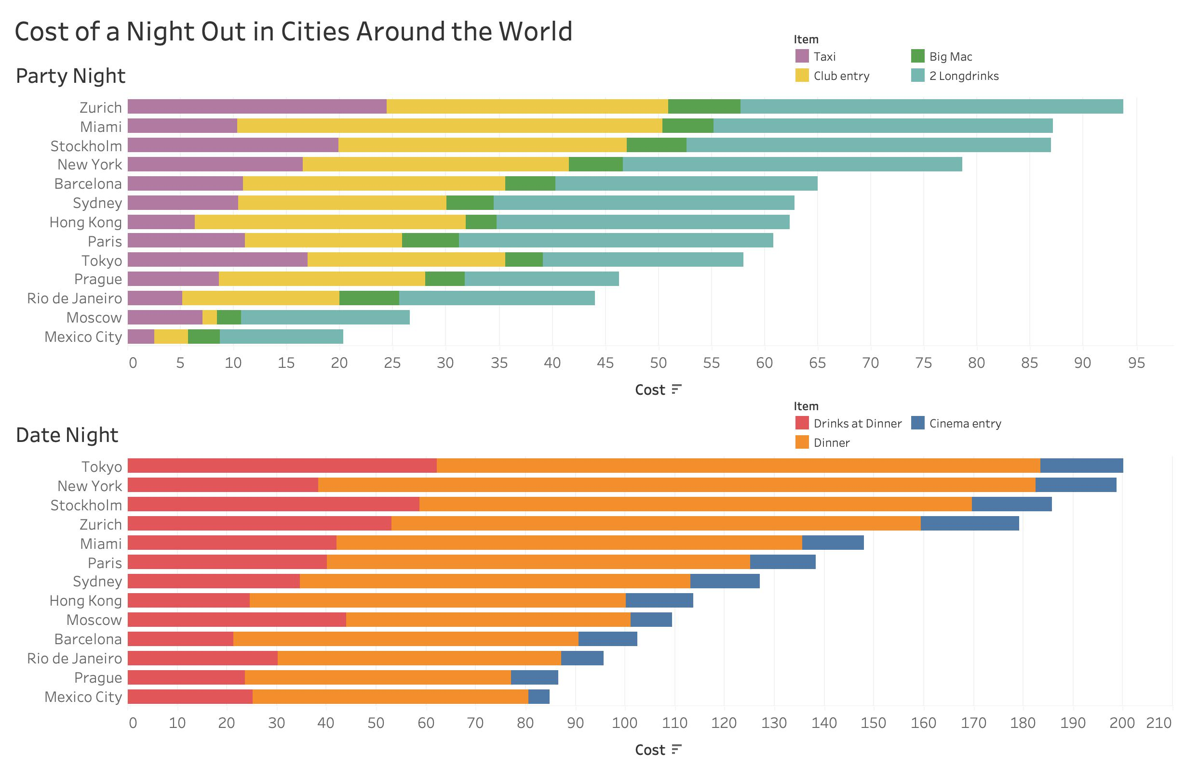Use an additional page if necessary. Remember, the purpose of visualization is “insight.” Take and include a screenshot of your visualization and include it below. Use Data Visualization Best Practices (see data visualization checklist).

Figure Caption. <replace this text with your figure caption>. Fall 2021

CGT 270 Data Visualization

Makeover Monday #1 (2018 Dataset)

**Resources**

Data Visualization Checklist: <http://stephanieevergreen.com/wp-content/uploads/2016/10/DataVizChecklist_May2016.pdf>

How to give constructive criticism: <https://personalexcellence.co/blog/constructive-criticism/>

Sample Makeovers <https://www.makeovermonday.co.uk/gallery/>

**Grading Rubric**

|  |  |  |  |
| --- | --- | --- | --- |
| **Excellent (21-25 pts)** | **Good**  **(10-20 pts)** | **Fair**  **(5 – 9 pts)** | **Needs Improvement**  **(0 – 4 pts)** |
| Meets **ALL** or most of these: Makeover is esthetically pleasing (color, perception), best practices followed (insightful), Correct dataset downloaded; provided an interesting point of view of the data; critiqued previous makeover, critique is constructive (indicates one thing that is done well, and one thing that could be done differently, what will be done to improve the visualization), assumptions (more than one) are listed. | Meets **MOST** of these: Makeover is esthetically pleasing (color, perception), best practices followed (insightful), Correct dataset downloaded; provided an interesting point of view of the data; critiqued previous makeover, critique is constructive (indicates one thing that is done well, and one thing that could be done differently, what will be done to improve the  visualization), assumptions (more than one) are listed. | Consistently meets **SOME** of these: Makeover is esthetically pleasing (color, perception), best practices followed (insightful), Correct dataset downloaded; provided an interesting point of view of the data; critiqued previous makeover, critique is constructive  (indicates one thing that is done well, and one thing that could be done differently, what will be done to improve the  visualization), assumptions (more than one) are listed. | Little to no evidence of the understanding of the data visualization process.  Lackluster makeover or no makeover.  Little effort. |

Fall 2021